DIS-Eur-Vinca-Figurine-male-135mm

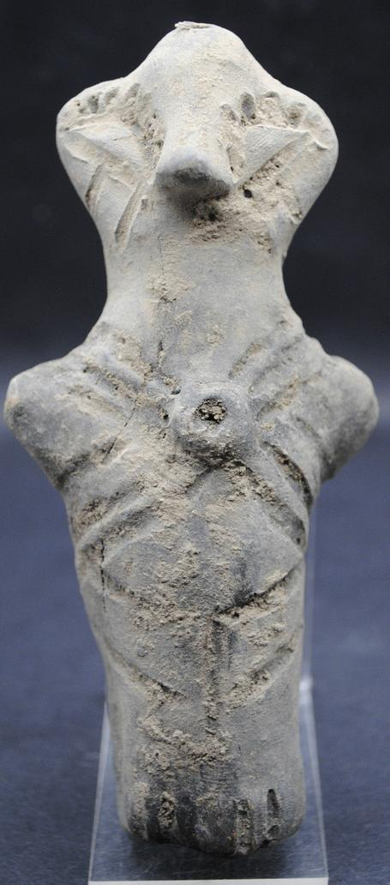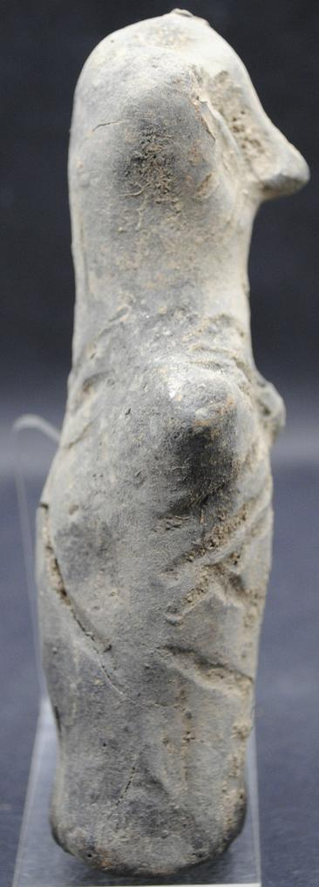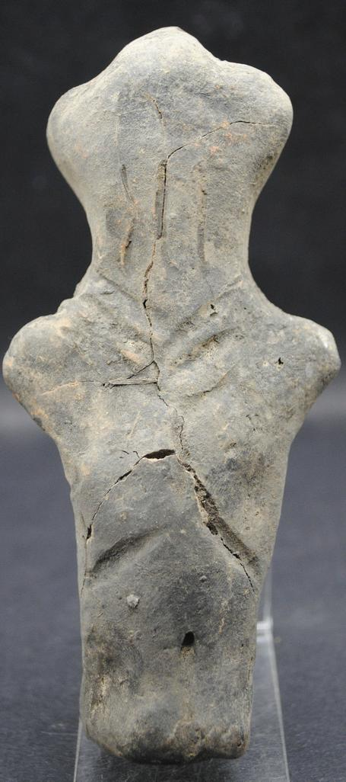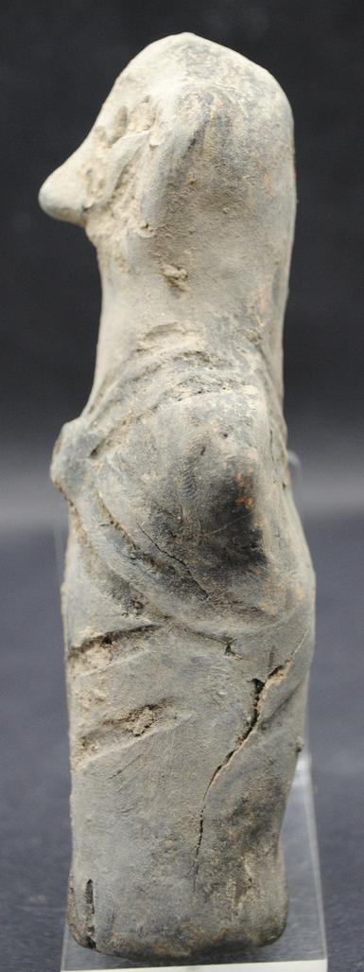

Formal Label: Vinca Neolithic ceramic male figurine with gorget, ca. 4500 BCE-13.5 cm

Accession Number: GN778.32.A6

Date or Time Horizon: ca. 4500 BCE

Geographical Area: Balkans

Cultural Affiliation: Vinca

Medium: Terracotta

Dimensions: H 135 mm x W 62mm

Weight:

Condition: Some cracks but no repairs.

Provenance: Ancient-Artefacts-UK 11 Wessex Road, Didcot, Oxfordshire, ox11 8bu, United Kingdom.

**References:**

**Discussion:**